<https://blog.csdn.net/yifanSJ/article/details/78598125>

1、WHILE……DO……END WHILE

CREATE TABLE `emp` (

`id` int(11) DEFAULT NULL

) ENGINE=InnoDB DEFAULT CHARSET=utf8;

CREATE DEFINER=`skip-grants user`@`skip-grants host` PROCEDURE `test`()

BEGIN

declare a int default 0;

while a<5 DO

insert into emp values(a);

set a = a+1;

end WHILE;

end

call test();

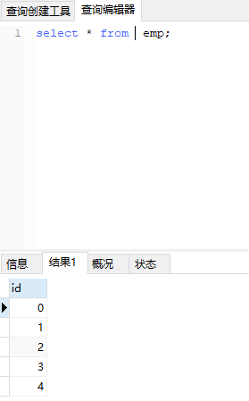

2、REPEAT……UNTIL END REPEAT

create procedure test()

BEGIN

declare a int default 0;

REPEAT

insert into emp value(a);

set a=a+1;

until a>4

end repeat;

end

call test();

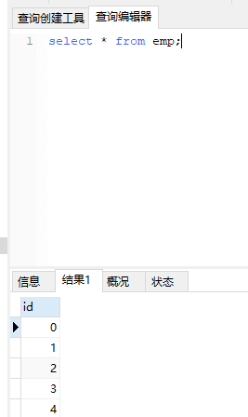

3、LOOP……END LOOP

create procedure test()

BEGIN

declare a int default 0;

lp1: LOOP

insert into emp value(a);

set a=a+1;

if a>5 THEN

leave lp1;

end if;

end LOOP;

END

